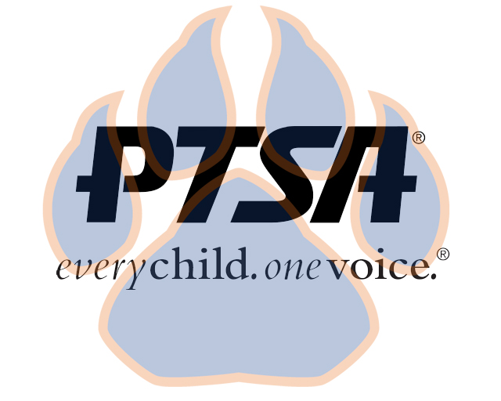
General Membership Minutes
March 24, 2022

PTA's mission is to make every child’s potential a reality by engaging and empowering families and communities to advocate for all children.
Agenda Item | Presenter | Action Taken/Needed/Notes
- Welcome, Call to Order, and Intros | Elizabeth Trebelhorn, President & | Call to Order  Quorum Met
- Meeting Minutes from 10.28.21 Review and Approval | Elizabeth Trebelhorn, President | Motion to approve minutes:  Donna Gay  Second:  Jay Kirkman
- Treasurers Report and Budget Review  - Principal’s Report  - Committee Chair Vacancies | Review report and budget  Mrs. Sams gave update on activities that will be happening during Spring Break. Report Cards and Summit Reports are being sent home. After break, end-of-year testing will start. Britney Howell spoke about extended services offered to students. We are also a pilot district for the L3 Coalition for standardized testing, working on a prototype and in need of parent feedback on standardized testing. There was also discussion about student transition back into school post-covid and how it has affected student behavior, learning, and mental health. Also discussion about more parent communication to come. Britney also discussed online registration process.  Stephanie Potter and Janie Cambron have had to step down as committee chairs.
- Committee Reports | Healthy Schools – Jill Stoltz – Getting ready for Earth Day activities. 3-day event. The Franklin County solid waste coordinator will be onsite with students to discuss litter and recycling. There will also be a community cleanup in south Frankfort. Connie Lemley and Katie Murphy will be working with students on outdoor projects. Need volunteers to help out on 4/21 and 4/22.  Advocacy – Stormey Prieskop – Discussed approval of student sponsorship form; the library applied for opportunity to get LGBTQIA+ books for students; seeking out opportunities for GLSEN training for adults; spoke with librarian about finding a safe space for students; possibility of resource center available for parents  Staff Appreciation – Donna Gay – Discussed preparation for staff appreciation week the first week of May with a Derby theme, and other stuff all week. Be on the lookout for help needed for volunteers to bring food and gift cards.  Staff loved the coffee truck. Trying to maybe get another one scheduled before the end of the year.  Student Appreciation Week – Elizabeth Trebelhorn – Gathering ideas from students on how to celebrate; Big Green Monster for all the students; maybe a glow party
- Closing Comments | Elizabeth Trebelhorn – Elections will be held at next general membership meeting, also SBDM elections coming up | Motion to Adjourn:  Jill Stoltz  Second: Donna Gay

