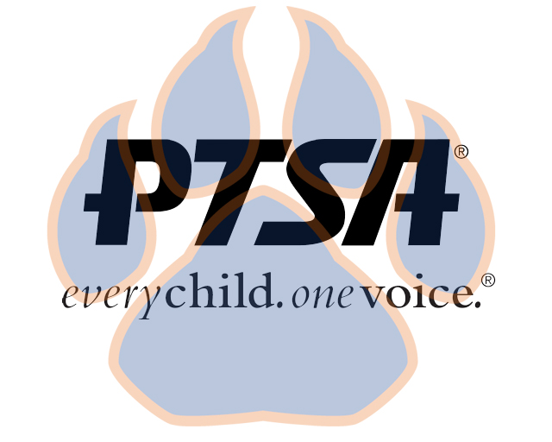
General Membership Meeting
February 24, 2021
4:45pm- 5:45pm (EST)
SSS Zoom

PTA's mission is to make every child’s potential a reality by engaging and empowering families and communities to advocate for all children.
Agenda Item | Presenter | Action Taken/Needed/Notes
- Welcome, Call to Order, and Intros/Roll Call | Elizabeth Trebelhorn, President &  Cathy Lindsey, Secretary | Call to Order  Roll Call  Verify Quorum Present
- Meeting Minutes from 2.8.2021 Review and Approval* | Elizabeth Trebelhorn, President | Motion to Approve*
- Treasurers Report  - Playground | Jennifer Walters, Treasurer  Elizabeth Trebelhorn
- Introducing STEM Extension | Katie Murphy, STEM Extension Teacher
- Vice President Updates | Robin Winkfield, VP Membership  Jay Kirkman, VP Ways and Means  Natalee’ Cleveland, VP Communications  Crystal Hardy, VP Programs
- Committee Updates | Donna Gay, Staff Appreciation  Class Reps, Janie Cambron and Jill Stoltz  Student Leadership, Sheree Brown  Advocacy, Diana Espinoza  Business Development, David Dickerson  Welcoming Families, Katie Carney  Reflections, Stephanie Potter
- Financial Review Committee  - May Elections | Elizabeth Trebelhorn, President  Elizabeth Trebelhorn, President
- Principal Report | Sam Sams, SSS Principal
- Other Related Updates (SBDM, FIBOE, etc) | All Members
- Closing, Comments, Questions | Elizabeth Trebelhorn, President | Motion to Approve*
Upcoming Dates:
March 16th @4:30 - SBDM Meeting
May 3rd- 4th General Membership Meeting/Elections @ 4:45 PM

