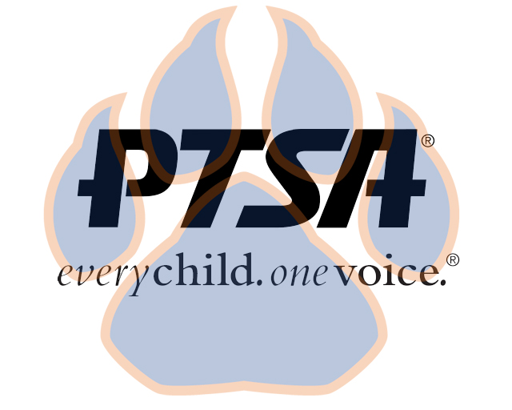
Board Meeting Minutes
September 20, 2021
5:30pm- 6:30pm (EST)
Zoom

PTA's mission is to make every child’s potential a reality by engaging and empowering families and communities to advocate for all children.
Agenda Item | Presenter | Action Taken/Needed/Notes
- Welcome, Call to Order, and Intros/Roll Call | Elizabeth Trebelhorn, President  Attendees: Elizabeth Trebelhorn, Cathy Lindsey, Jennifer Walters, Crystal Emberton-Hardy, Janie Cambron, Jill Stoltz, Jay Kirkman, Stephanie Potter, Donna Gay, Sheree Brown, Margaret Tillman, Diana Espinoza, Bart Ligouri, Stormey Prieskop, Katie Murphy | Call to Order  Roll Call  Quorum present
- Meeting Minutes from 7.19.21 | Elizabeth Trebelhorn, President | Motion to Approve:  Diana Esponoza  Second:  Jill Stoltz
- Treasurers Report and Budget Update | Jennifer Walters, Treasurer
- Vacancies and Committee Chair Appointments | Elizabeth Trebelhorn, President  -Elizabeth introduced Stormey Prieskop as new Committee Chair of Advocacy  -Current vacancy in Welcoming Families Committee, Elizabeth shared names of those interested
- Equity Assessment | Elizabeth Trebelhorn, President  -People need to fill out, we need to see data of our school and community needs, survey should be completed as data assessment
- Committee Updates/Workplans | DEI, Margaret Tillman  Workplan: Develop DEI Committee Mission Statement, Objectives, Action Steps  This is a full board responsibility that reflects diversity and inclusivity.  Healthy Schools, Jill Stoltz  Workplan: 3 Goals – Eat, Live, Move  Eat – Plan to create document about what is most important; Cookbook; Master Chef’s Challenge  Live – Reusable water bottles; Recycling cans in classrooms; Earth Day event  Move – National Walk/Bike to School day; Yoga videos; Communication needs to be improved about sports opportunities  Cultural Arts, Stephanie Potter  Scholastic Book Fair, Sept. 27-Oct. 1 – possibility of scholarships for students to get books  Reflections – Art, Literacy, Music  Permission slips are out to students; Dana Parker will run through art classes; PTSA purchased good sketch paper for this; Stephanie is securing judges; Judges selections due to KY PTSA by Dec. 15; Jennifer will assist with video awards show  Staff Appreciation, Donna Gay  Goal: Focus on staff and administration to support and encourage them.  Get parents involved and get them to donate.  Get student leaders involved.  Staff has been surveyed about things they like: Food and gift cards  1st Week in May is Staff Appreciation Week.  Checking out possibility for a special parking place for Staff Member of the Week.  Working on getting a food truck  Volunteers, Janie Cambron  Volunteer training set for Sept. 23  Student Leaders, Sheree’ Brown  Working with students to move plans forward  Business Development, David Dickerson  Elizabeth reported that SpiritWear Store is open with CLS | Motion to Approve DEI Workplan:  Bart Ligouri  Second:  Margaret Tillman  Motion to Approve Healthy Schools Workplan:  Diana Espinoza  Second:  Bart Ligouri  Motion to Approve Staff Appreciation Workplan:  Diana Espinoza  Second:  Jennifer Walters
- Upcoming Events | Elizabeth Trebelhorn | Volunteer Training  Parent/Teacher Conferences  Book Fair
- Other Related Updates (SBDM, FIBOE, etc) | Student Code of Conduct will be discussed at SBDM meeting | Discipline Policy/Student Handbook
- Closing, Comments, Questions | Elizabeth Trebelhorn, President | Motion to Adjorn:  Cathy Lindsey  Second:  Stephanie Potter

