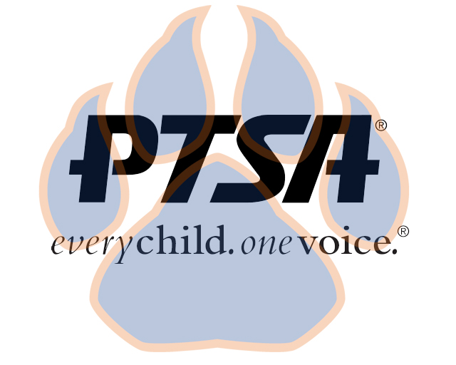
Board Meeting Minutes
August 24, 2020
5:30pm- 6:30pm (EST)
Via Zoom

PTA's mission is to make every child’s potential a reality by engaging and empowering families and communities to advocate for all children.

Members Present:  Members Absent:  Agenda Item | Presenter | Action Taken/Needed/Notes
- Welcome, Call to Order, and Intros/Roll Call | Elizabeth Trebelhorn, President calls meeting to order.  Cathy Lindsey, Secretary, completes roll call. A quorum was determined.
- Meeting Minutes from 5.7.20 Review and Approval* | Meeting minutes from 5.7.20 were reviewed. Meeting minutes were approved. | Motion to Approve:  Second:
- Treasurer’s Report
- Proposed Draft Budget | Eric Kennedy, Treasurer | Motion to Approve:  Second:
- Vice President Updates | Robin Winkfield, VP Membership  Jay Kirkman, VP Ways and Means  Natalee’ Cleveland, VP Communications  Crystal Hardy, VP Programs
- Committee Development | Elizabeth Trebelhorn, President | Motion to Approve:  Second:
- 2020-2021 Calendar | Elizabeth Trebelhorn, President | Motion to Approve:  Second:
- Principal Report | Sam Sams, SSS Principal
- Other Related Updates (SBDM, FIBOE, etc) | Elizabeth Trebelhorn, President
- Closing, Comments, Questions | Elizabeth Trebelhorn, President | Motion to Approve:  Second:
Upcoming Dates:
8/24 7:30 PM- Social Distance Social
9/2 4:45PM- 1st General Membership Meeting
9/15- SBDM Meeting

