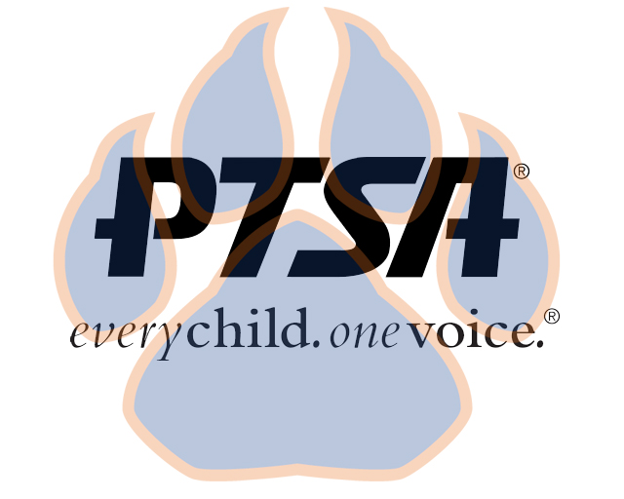
Board Meeting Minutes
July 19, 2021
5:30pm- 6:30pm (EST)
Zoom and In-person

PTA's mission is to make every child’s potential a reality by engaging and empowering families and communities to advocate for all children.
Agenda Item | Presenter | Action Taken/Needed/Notes
- Welcome, Call to Order, and Intros/Roll Call | Elizabeth Trebelhorn, President  Attendees: Elizabeth Trebelhorn, Jill Stoltz, Donna Gay, Diana Espinoza, Natalee Cleveland, Janie Cambron, Stephanie Potter, Jennifer Walters, Katie Carney | Call to Order  Roll Call  Verify Quorum Present
- Meeting Minutes from 5.3.21 Review and Approval* | Elizabeth Trebelhorn, President | Motion to Approve Board Meeting Minutes for May:  Katie Carney  Second:  Stephanie Potter  Motion to Approve Board Meeting Minutes for April:  Jennifer Walters  Second:  Katie Carney
- Treasurer’s Report | Elizabeth Trebelhorn, President – Financial review completed. $1,999.28 current balance
- Standing Rule Proposals  - Committee Chair Appointments  - Workplans | - Add student leader to board  - Change board meeting schedule  - Executive committee quorum change  - Change in standing committees – Class Rep to Volunteer, Reflections to Cultural Arts, Add Diversity and Inclusion, Healthy Schools, and Parent Cafe  Advocacy – Diana Espinoza  Business Development – David Dickerson  Volunteer – Janie Cambron  Healthy Schools – Jill Stoltz  Parent Café – TBD  Cultural Arts – Stephanie Potter  Staff Appreciation – Donna Gay  Staff Rep – Katie Murphy  Student Leader – TBD  Student Leadership – Sheree Brown  Welcoming Families – Katie Carney  Every committee to do workplan and submit to the board, with goals and objectives. Should focus on making students into leaders. | Motion to Approve:  Natalee Cleveland  Second:  Jennifer Walters  Motion to Approve:  Katie Carney  Second:  Natalee Cleveland
- Just Say Yes | Kindness campaign aspect – Possibly provide workbooks for students relating to students who are different than themselves. Would need parent support from Parent Café.
- Meeting Calendar | One general and one board meeting every quarter | Motion to Approve:  Katie Carney  Second:  Jill Stoltz
- Budget | Carry-over amount - $1,999.28  Estimated Income - $6,559.28  Estimated Expenses - $6,559.28 | Motion to Approve Budget:  Jennifer Walters  Second:  Cathy Lindsey
- Closing, Comments, Questions  - Adjourn | Membership Drive – Everyone can help out!  National Night Out coming August 3 at Farmers Market | Motion to Approve:  Diana Espinoza  Second:  Jay Kirkman  Motion to Adjourn:  Cathy Lindsey  Second:  Katie Carney

