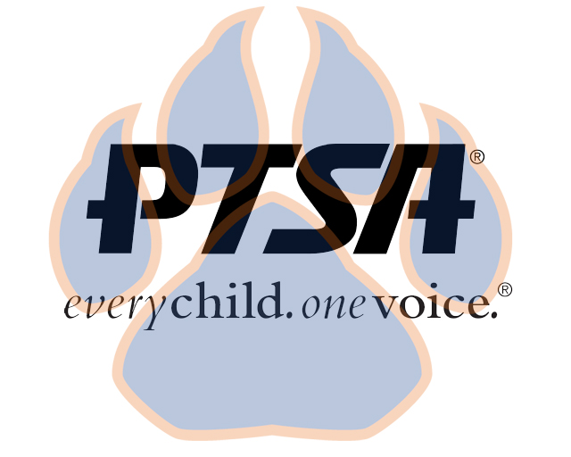
Board Meeting
September 20, 2021
5:30pm- 6:30pm (EST)
Zoom

PTA's mission is to make every child’s potential a reality by engaging and empowering families and communities to advocate for all children.
Agenda Item | Presenter | Action Taken/Needed/Notes
- Welcome, Call to Order, and Intros/Roll Call | Elizabeth Trebelhorn, President  Cathy Lindsey, Secretary | Call to Order  Roll Call  Verify Quorum Present
- Meeting Minutes from 7.19.21 | Elizabeth Trebelhorn, President | *Motion to Approve
- Treasurers Report and Budget Update | Jennifer Walters, Treasurer | *Motion to Approve
- Vacancies and Committee Chair Appointments | Elizabeth Trebelhorn, President | Welcome Stormey Prieskop  Welcoming Families (V) *Motion to Approve
- Equity Assessment | Elizabeth Trebelhorn, President
- Committee Updates/Workplans | DEI, Margaret Tillman  Healthy Schools, Jill Stoltz  Cultural Arts, Stephanie Potter  Staff Appreciation, Donna Gay  Volunteers, Janie Cambron  Business Development, David Dickerson  Student Leaders, Sheree’ Brown  Parent Café’s- Bart Ligouri  Advocacy- Stormey Preiskop  Welcoming Families- (Vacant) | *Motion to Approve Workplans:  -DEI  -HS  -CA  -SA
- Principal Report | Sam Sams, SSS Principal/ Sara Taylor, SSS Assistant Principal
- Upcoming Events | Elizabeth Trebelhorn | Volunteer Training  Parent/Teacher Conferences  Book Fair
- Other Related Updates (SBDM, FIBOE, etc) | All Members | Discipline Policy/Student Handbook
- Closing, Comments, Questions | Elizabeth Trebelhorn, President | Motion to Adjorn*
Upcoming Dates:
9/21- SBDM @ 4:30PM ZOOM
9/27- FIS BOE Meeting @ 6:00PM SSS
10/11- FIS BOE Meeting @ 6:00PM CO

10/26-SBDM @ 4:30 ZOOM
10/28-PTSA 2nd General Membership Meeting @4:45 SSS Riverview Café’

