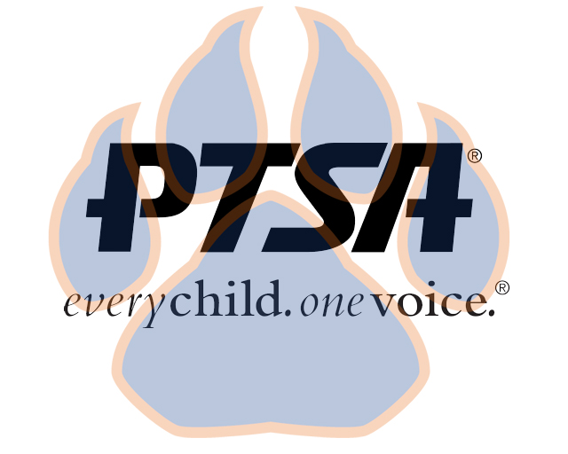
Board Meeting
November 9, 2020
5:30pm- 6:30pm (EST)
Zoom

PTA's mission is to make every child’s potential a reality by engaging and empowering families and communities to advocate for all children.
Agenda Item | Presenter | Action Taken/Needed/Notes
- Welcome, Call to Order, and Intros/Roll Call | Elizabeth Trebelhorn, President &  Cathy Lindsey, Secretary | Call to Order  Roll Call  Verify Quorum Present
- Meeting Minutes from 10.12.20 Review and Approval* | Elizabeth Trebelhorn, President | Motion to Approve*
- Treasurers Report & Budget | Jennifer Walters, Treasurer
- Standing Rules | Elizabeth Trebelhorn | *Need to approve language for Teacher/Staff Representative  *Upon approval, appoint representative
- Vice President and Committee Updates/Workplans/Approvals | Robin Winkfield, VP Membership  Jay Kirkman, VP Ways and Means  Natalee’ Cleveland, VP Communications  Crystal Hardy, VP Programs  Stephanie Potter, Reflections  Diana Espinoza, Advocacy  Donna Gay, Staff Appreciation  David Dickerson, Business Development  Katie Carney, Welcoming Families  Shereè Brown, Student Leadership  Janie Cambron, Class Reps | *Approve Advocacy Priorities
- Principal Report | Sam Sams, SSS Principal/ Sara Taylor, SSS Assistant Principal
- Upcoming Events | Elizabeth Trebelhorn
- Other Related Updates (SBDM, FIBOE, etc) | All Members
- Closing, Comments, Questions | Elizabeth Trebelhorn, President | Motion to Approve*
Upcoming Dates:
11/17- SBDM
11/18- 2nd General Membership Meeting @ 4:45PM
12/5- Advocacy Training
12/14- Board Meeting

