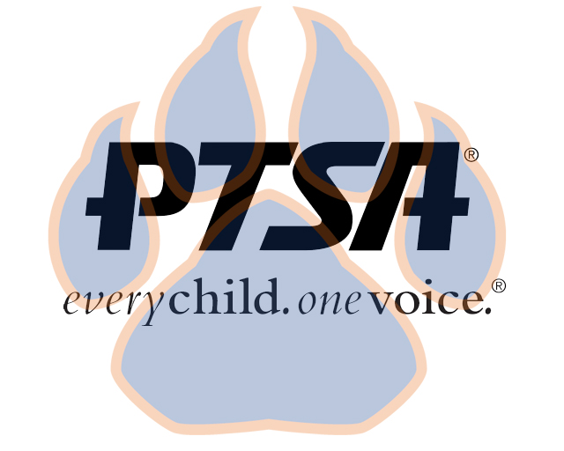
Special Board Meeting
November 17, 2020
6:30pm- 7:30pm (EST)
Zoom

PTA's mission is to make every child’s potential a reality by engaging and empowering families and communities to advocate for all children.
Agenda Item | Presenter | Action Taken/Needed/Notes
- Welcome, Call to Order, and Intros/Roll Call | Elizabeth Trebelhorn, President  Vice President | Call to Order  Roll Call  Verify Quorum Present
- Meeting Minutes from 10.12.20 and 11.9.20 Review and Approval* | Elizabeth Trebelhorn, President | Motion to Approve*
- Playground Discussion | Guests: Bobby Driskell
- Closing, Comments, Questions | Elizabeth Trebelhorn, President | Motion to Approve*
Upcoming Dates:
11/18- 2nd General Membership Meeting @ 4:45PM
11/18- Implicit Bias Training @ 6:00PM
12/5- Advocacy Training
12/14- Board Meeting

