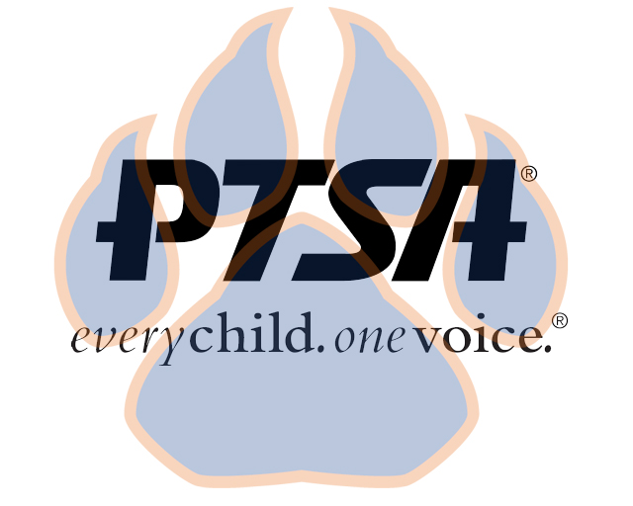
General Membership Meeting
May 19, 2022
4:45pm- 5:45pm (EST)
SSS Library’ & Zoom

PTA's mission is to make every child’s potential a reality by engaging and empowering families and communities to advocate for all children.
Agenda Item | Presenter | Action Taken/Needed/Notes
- Welcome, Introductions, and Call to order | Elizabeth Trebelhorn, President  Cathy Lindsey, Secretary | Call to Order  Verify Quorum Present
- Meeting Minutes from 3.24.22 | Cathy Lindsey, Secretary | *Motion to Approve
- Treasurers Report & Budget | Jennifer Walters, Treasurer | Financial Review Committee Appointments  Convention- Summer Spending
- PTSA Election | Elizabeth Trebelhorn, President | *Motion to Approve
- Family- School Partnership Survey Results | Elizabeth Trebelhorn, President
- Committee Updates & next year goals | Advocacy, Stormey Prieskop  Business Development, David Dickerson  Diversity, Equity, and Inclusion, Margaret Tillman  Healthy Schools, Jill Stoltz  Parent Café’, Bart Ligouri  Staff Appreciation, Donna Gay  Student Leadership, Sheree’ Brown  Welcoming Families- Meagan Harrod  Cultural Arts- Vacant  Class Reps-Vacant | Binders  PTSA space at school
- Principal Report | Sam Sams, SSS Principal/ Sara Taylor, SSS Assistant Principal
- Upcoming Events | Elizabeth Trebelhorn, President
- Other Related Updates (SBDM, FIBOE, etc) | All Members | Discipline Policy  Superintendent Search
- Closing, Comments, Questions | Elizabeth Trebelhorn, President | Motion to Adjorn*

Upcoming Dates:

KY PTA Convention in Louisville- July 15-16th ($60 before June 15, $75 after). Hotel special rate is $145 for 2 queens

