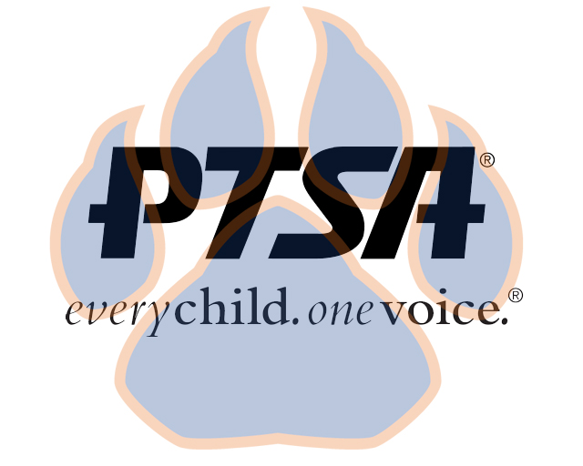
General Membership Meeting Minutes
Sept. 2, 2020
4:45pm- 5:45pm (EST)
SSS Map Area and Zoom

PTA's mission is to make every child’s potential a reality by engaging and empowering families and communities to advocate for all children.

Members Present:  Agenda Item | Seven on Zoom; Six in Person – Meets quorum  Presenter | Action Taken/Needed/Notes
- Welcome, Call to Order, and Intros/Roll Call | Elizabeth Trebelhorn, President, calls meeting to order.  Cathy Lindsey, Secretary, completes roll call.  A quorum was determined.
- PTSA 101 | Elizabeth discussed the basics of PTSA as a non-profit, action/advocacy group
- Meeting Minutes from 8.24.20 Review and Approval* | Meeting minutes from 8.24.20 were reviewed. Meeting minutes were approved. | Motion to Approve:  Cathy Lindsey  Second:  Jay Kirkman
- Proposed Budget | Eric Kennedy, Treasurer  - Amendment proposed to approve using money left over at the end of the year as startup money for the following year.  - Presented budget as amended for approval | Motion to Approve:  Jennifer Oberlin  Second:  Janie Cambron
- Vice President Updates | Robin Winkfield, VP Membership  -Membership drive underway, currently 84 registered  -Challenged all members to reach out to five families  Jay Kirkman, VP Ways and Means  - Discussed importance of offering a Return on Investment to potential sponsoring businesses  Natalee’ Cleveland, VP Communications  -Working with Family Connection group  -Discussed family survey as way to get input from families to learn and meet their needs  Crystal Hardy, VP Programs  -Discussed how Reflections would work virtually, will be working with extensions teachers to get some entries, looking for someone to chair Reflections Committee  -This year’s Reflection theme is I matter because…
- Committee Development | Elizabeth Trebelhorn, President  -Committees discussed include Staff Appreciation, Reflections, Class Rep./Family Connection, Financial Review, Student Leadership, Advocacy, Welcoming Committee/Community & Family Support, and Business Development  -We need help to help others.
- 2020-2021 Calendar | Elizabeth Trebelhorn, President  -General membership meetings will be held on September 2, November 18, February 24 and May 3.
- Other Related Updates (SBDM, FIBOE, etc) | All Members  -Diana Espinoza offered to translate materials to Spanish  -Eric gave an SBDM update
- Closing, Comments, Questions | Elizabeth Trebelhorn, President | Motion to Adjourn:  Cathy Lindsey  Second:  Katie Carney
Upcoming Dates:
9/15- SBDM Meeting

