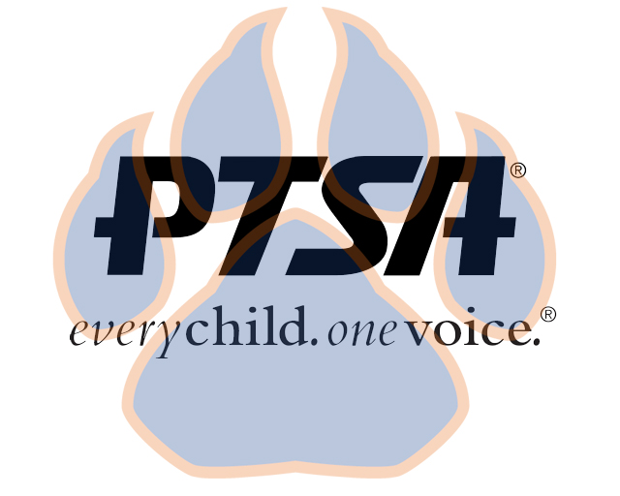
General Membership Minutes
Oct. 28, 2021

PTA's mission is to make every child’s potential a reality by engaging and empowering families and communities to advocate for all children.
Agenda Item | Presenter | Action Taken/Needed/Notes
- Welcome, Call to Order, and Intros | Elizabeth Trebelhorn, President &  Cathy Lindsey, Secretary | Call to Order  Quorum Met
- Meeting Minutes from 7.29.21 Review and Approval | Elizabeth Trebelhorn, President | Motion to approve minutes:  Stormey Proeskop  Second:  Donna Gay
- Treasurers Report and Budget Review  - Committee Chair vacancy | Review report and budget  Welcome Committee – description of position and committee. Any volunteers?  Meagan Harrod agreed to be chair. Unanimous vote approved.
- Committee Reports | Advocacy – Stormey Prieskop – Discussed canned food drive for Thanksgiving, Book and clothing swap in the spring, and Christmas break food basket collection  Business Development – Natalie Wilkerson – Spirit Wear has arrived. It was a good fundraiser and there is extra inventory to sell.  Cultural Arts – Stephanie Potter – Reflections deadline is Nov. 15, theme is I will change the world by…, She has secured judges for literature and visual arts, supplemented paper for art supplies, has collected five boxes of books for book sale, Stormey volunteered room for book storage. Talent Show – asking for volunteers to help.  DEI – Equity audit by board, we are looking at ways we want to improve, we get cultural crayons, Margaret has developed a plan.  Healthy Schools & Wellness – Jill Stoltz – Committee reviewed wellness policy and will make some suggestions to submit to SBDM. Ideas: work with Farm to School program, maybe a Virtual Cookbook with affordable, easy and healthy recipes, get recycle bins in all classrooms. Katie Murphy will gather recycling when needed. Move component in plan – maybe a Bike to School event, BMX cyclist could maybe speak at school.  Parent Café – Bart Ligouri – Training Institute will be Dec. 7-8, partner organizations will complete training.  Staff Appreciation – Plan on doing something each month, staff wants coffee and coffee supplies, Dueling Chopsticks Food Truck for staff on Oct. 29, Holiday luncheon a possibility  Janie Cambron discussed two volunteer training opportuntities.  SBDM – Natalee Cleveland gave review – student behavior policy.
- Closing Comments | Elizabeth Trebelhorn | Motion to Adjourn:  Cathy Lindsey  Second: Stephanie Potter

