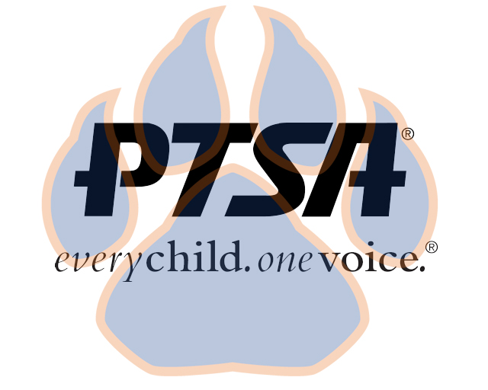
General Membership Meeting
September 2, 2020
4:45pm- 5:45pm (EST)
SSS Map Area & Zoom

PTA's mission is to make every child’s potential a reality by engaging and empowering families and communities to advocate for all children.
Agenda Item | Presenter | Action Taken/Needed/Notes
- Welcome, Call to Order, and Intros/Roll Call | Elizabeth Trebelhorn, President &  Cathy Lindsey, Secretary | Call to Order  Roll Call  Verify Quorum Present
- PTSA 101 | Elizabeth Trebelhorn, President
- Meeting Minutes from 8.24.20 Review and Approval* | Elizabeth Trebelhorn, President | Motion to Approve*
- Proposed Budget | Eric Kennedy, Treasurer | Motion to Approve*
- Vice President Updates | Robin Winkfield, VP Membership  Jay Kirkman, VP Ways and Means  Natalee’ Cleveland, VP Communications  Crystal Hardy, VP Programs
- Committee Lists | Elizabeth Trebelhorn, President
- 2020-2021 Calendar | Elizabeth Trebelhorn, President
- Principal Report | Sam Sams, SSS Principal
- Other Related Updates (SBDM, FIBOE, etc) | All Members
- Closing, Comments, Questions | Elizabeth Trebelhorn, President | Motion to Approve*
Upcoming Dates:
9/15- SBDM Meeting
11/18- 2nd General Membership Meeting @ 4:45PM
2/24- 3rd General Membership Meeting @ 4:45PM
5/3- 4th General Membership Meeting @ 4:45 PM

