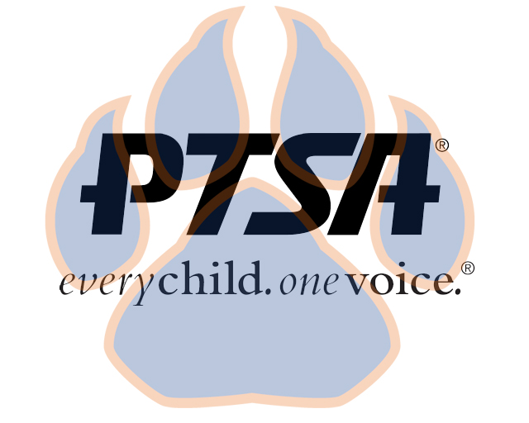
Board Meeting
May 9, 2022
5:30pm- 6:30pm (EST)
Zoom

PTA's mission is to make every child’s potential a reality by engaging and empowering families and communities to advocate for all children.
Agenda Item | Presenter | Action Taken/Needed/Notes
- Welcome, Call to Order, and Intros/Roll Call | Elizabeth Trebelhorn, President  Cathy Lindsey, Secretary | Record*  Call to Order  Roll Call  Verify Quorum Present
- Meeting Minutes from 2.21.22 | Elizabeth Trebelhorn, President | *Motion to Approve
- Treasurers Report and Budget Update | Jennifer Walters, Treasurer
- Student Appreciation Week | Elizabeth Trebelhorn, President | *Motion to Approve Budget
- Family Engagement Survey | Elizabeth Trebelhorn, President  Sam Sams, Principal
- Committee Updates/Workplans | Healthy Schools, Jill Stoltz  Staff Appreciation, Donna Gay  Parent Café’s- Bart Ligouri  Advocacy- Stormey Preiskop  DEI, Margaret Tillman  Welcoming Families-Meagan Harrod  Student Leaders, Sheree’Brown  Business Development, David Dickerson | *Motion to Approve Spending
- Principal Report | Sam Sams, SSS Principal/ Sara Taylor, SSS Assistant Principal
- Other Related Updates (SBDM, FIBOE, etc) | All Members | Elections (SBDM & PTSA)  Superintendent Search  Nominations Committee  Financial Committee
- Closing, Comments, Questions | Elizabeth Trebelhorn, President | Motion to Adjorn*

