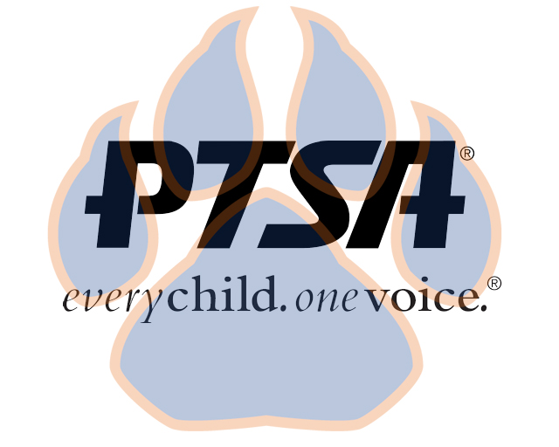
Board Meeting
February 21, 2021
5:30pm- 6:30pm (EST)
Zoom

PTA's mission is to make every child’s potential a reality by engaging and empowering families and communities to advocate for all children.
Agenda Item | Presenter | Action Taken/Needed/Notes
- Welcome, Call to Order, and Intros/Roll Call | Elizabeth Trebelhorn, President  Cathy Lindsey, Secretary | Call to Order  Roll Call  Verify Quorum Present
- Meeting Minutes from 9.20.21 | Elizabeth Trebelhorn, President | *Motion to Approve
- Treasurers Report and Budget Update | Jennifer Walters, Treasurer | *Motion to Approve
- Vacancies and Committee Chair Appointments | Elizabeth Trebelhorn, President | Student Leaders  Volunteer  Cultural Arts
- Equity Assessment | Elizabeth Trebelhorn, President
- Committee Updates/Workplans | Healthy Schools, Jill Stoltz  Staff Appreciation, Donna Gay  Parent Café’s- Bart Ligouri  Advocacy- Stormey Preiskop  DEI, Margaret Tillman  Welcoming Families-Meagan Harrod  Student Leaders, Sheree’ Brown  Business Development, David Dickerson | *Motion to Approve Spending
- Principal Report | Sam Sams, SSS Principal/ Sara Taylor, SSS Assistant Principal
- Other Related Updates (SBDM, FIBOE, etc) | All Members | Elections (SBDM & PTSA)
- Closing, Comments, Questions | Elizabeth Trebelhorn, President | Motion to Adjorn*
Upcoming Dates:
2/22- SBDM @ 4:30PM ZOOM
2/28- FIS BOE Meeting @ 6:00PM SSS
3/14- FIS BOE Meeting @ 6:00PM CO

3/15 -SBDM @ 4:30 ZOOM
3/24-PTSA 3rd General Membership Meeting @4:45 SSS Riverview Café’

