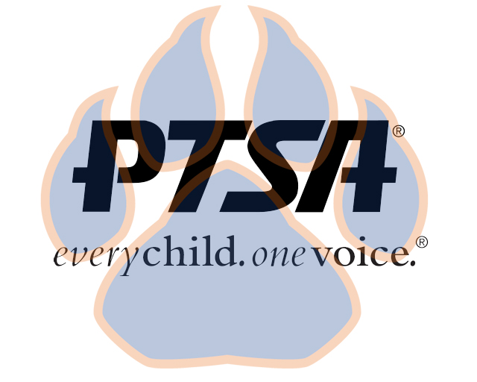
Board Meeting
October 12, 2020
5:30pm- 6:30pm (EST)
Zoom

PTA's mission is to make every child’s potential a reality by engaging and empowering families and communities to advocate for all children.
Agenda Item | Presenter | Action Taken/Needed/Notes
- Welcome, Call to Order, and Intros/Roll Call | Elizabeth Trebelhorn, President &  Cathy Lindsey, Secretary | Call to Order  Roll Call  Verify Quorum Present
- Meeting Minutes from 9.14.20 Review and Approval* | Elizabeth Trebelhorn, President | Motion to Approve*
- Treasurers Report & Budget | Elizabeth Trebelhorn, President
- Standing Rules |  | Teacher/Staff Representative
- Vice President Updates | Robin Winkfield, VP Membership  Jay Kirkman, VP Ways and Means  Natalee’ Cleveland, VP Communications  Crystal Hardy, VP Programs
- Committee Chair Updates | Elizabeth Trebelhorn, President
- Principal Report | Sam Sams, SSS Principal/ Sara Taylor, SSS Assistant Principal
- Upcoming Events | Elizabeth Trebelhorn, President | Pumpkin Decorating Contest  Others
- Other Related Updates (SBDM, FIBOE, etc) | All Members
- Closing, Comments, Questions | Elizabeth Trebelhorn, President | Motion to Approve*
Upcoming Dates:
11/9- Board Meeting
11/18- 2nd General Membership Meeting @ 4:45PM
12/14- Board Meeting

